***NAME WALEED KRAM***

***ROLL NO 20P-0640***

TASK # 1

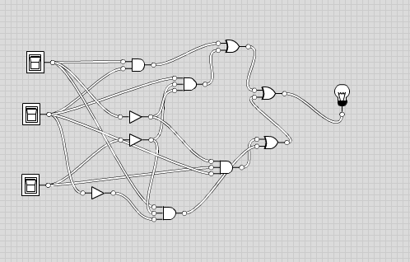

**TASK #2** 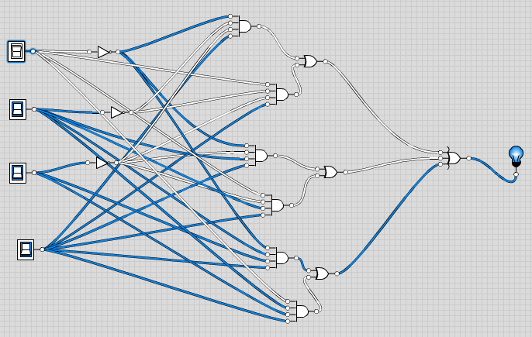

**TASK # 3**

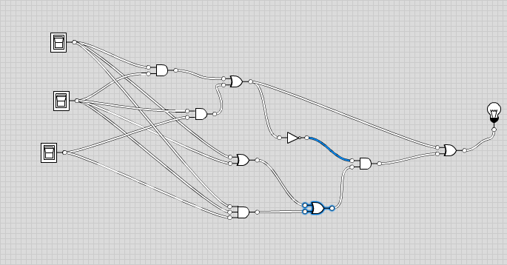

**TASK # 5**

